MCA 2nd Semester

**Name**:-Lakshita Joshi

**Roll no.:-**16

**Subject**:-Cloud Coumputing

**Topic**:-Amazon Sumerian

**Introduction to Amazon Sumerian**

Amazon Sumerian is a cloud-based platform that simplifies the creation and deployment of immersive experiences. It allows developers and designers to build interactive 3D environments without requiring specialized programming or 3D graphics expertise. Sumerian's intuitive interface and pre-built assets enable users to quickly prototype and deploy VR, AR, and 3D applications across a variety of devices, including VR headsets, mobile phones, and web browsers.

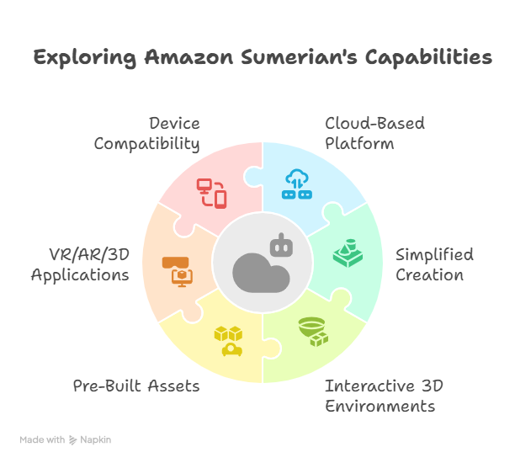

**Key Features**

Sumerian boasts a range of features designed to streamline the development process:

*Web-Based Editor*: Sumerian's editor runs entirely in a web browser, eliminating the need for local installations and allowing for collaborative development.

Drag-and-Drop Interface: The intuitive drag-and-drop interface simplifies scene creation and object manipulation.

Pre-Built Assets: Sumerian provides a library of pre-built 3D models, environments, and animations, accelerating the development process.

Scripting: Sumerian supports JavaScript scripting, allowing developers to add interactivity and logic to their scenes.

AWS Integration: Sumerian seamlessly integrates with other AWS services, such as Amazon Lex for conversational interfaces, Amazon Polly for text-to-speech, and AWS Lambda for serverless computing.

Cross-Platform Compatibility: Sumerian applications can be deployed to a variety of devices, including VR headsets (Oculus, HTC Vive), AR-enabled mobile devices (iOS, Android), and web browsers.

Hosting and Deployment: Sumerian handles the hosting and deployment of applications, simplifying the process of making them accessible to users.

State Machine Editor: The state machine editor allows developers to visually define the behavior of entities within the scene, making it easier to create complex interactions.

Entity Component System (ECS): Sumerian uses an ECS architecture, which promotes modularity and reusability of components.

Collaboration: Multiple users can collaborate on the same Sumerian project simultaneously.

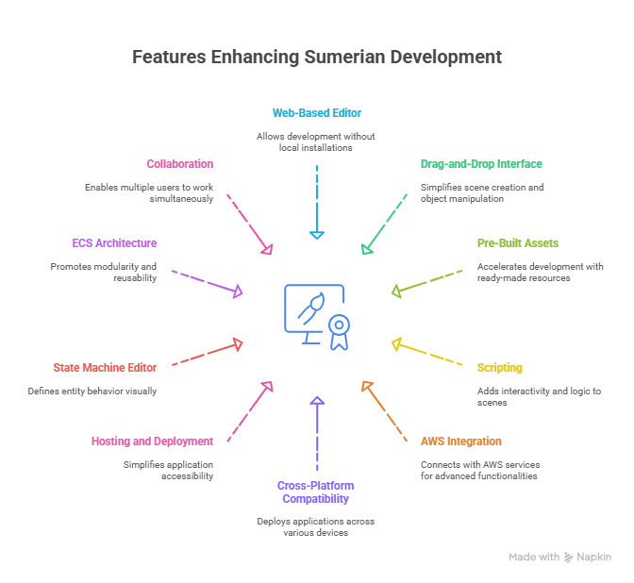

**Benefits of Using Amazon Sumerian**

**Using Amazon Sumerian offers several advantages**:

Simplified Development: Sumerian's intuitive interface and pre-built assets simplify the development process, reducing the time and effort required to create immersive experiences.

No Specialized Expertise Required: Sumerian allows users without specialized programming or 3D graphics expertise to create interactive 3D environments.

Cost-Effective: Sumerian's pay-as-you-go pricing model makes it a cost-effective solution for developing and deploying VR, AR, and 3D applications.

Scalability: Sumerian leverages the scalability of the AWS cloud, ensuring that applications can handle a large number of users.

Cross-Platform Compatibility: Sumerian's cross-platform compatibility allows applications to reach a wider audience.

Integration with AWS Services: Sumerian's integration with other AWS services enables developers to create more sophisticated and feature-rich applications.

Rapid Prototyping: Sumerian's ease of use allows for rapid prototyping and iteration, enabling developers to quickly test and refine their ideas.

